SPAM MAIL DETECTOR USING MACHINE LEARNING
QSkill AI & Machine Learning Internship
Submitted By:
Kandhi Charan Yadav
B.Tech Computer Science and Engineering
SR University

Abstract:
Spam emails and messages are a common problem in digital communication. This project aims to develop a machine learning model that can automatically classify SMS messages as Spam or Ham (Not Spam). Natural Language Processing (NLP) techniques and a Naive Bayes classifier were used to build the prediction model. The model achieved high accuracy and successfully identified spam messages.
Introduction:
Spam messages are unwanted messages sent to users for advertising, fraud, or promotional purposes. Detecting spam messages manually is difficult when dealing with large amounts of data. Machine Learning provides an efficient solution by automatically learning patterns from previous messages and classifying new messages accordingly.
This project uses the SMS Spam Collection dataset and applies text preprocessing, TF-IDF vectorization, and the Naive Bayes algorithm to classify messages.
Objective:
The main objectives of this project are:
- To classify SMS messages as Spam or Ham.
- To perform text preprocessing and feature extraction.
- To train a machine learning classification model.
- To evaluate model performance using standard metrics.
Dataset Description:
The SMS Spam Collection dataset contains SMS messages labeled as either Spam or Ham.
Dataset Statistics
- Total Messages: 5572
- Ham Messages: 4825
- Spam Messages: 747
The dataset consists of two main columns:
- Label (Spam/Ham)
- Message Text
Methodology:
The project follows the following steps:
Step 1: Data Collection
The SMS Spam Collection dataset was loaded using Pandas.
Step 2: Data Preprocessing
- Removed unnecessary columns.
- Renamed columns for better readability.
- Converted labels into numerical format:
  - Ham = 0
  - Spam = 1
Step 3: Feature Extraction
TF-IDF (Term Frequency-Inverse Document Frequency) vectorization was used to convert text messages into numerical features.
Step 4: Train-Test Split
The dataset was divided into:
- Training Data: 80%
- Testing Data: 20%
Step 5: Model Training
A Multinomial Naive Bayes classifier was trained using the processed dataset.
Step 6: Model Evaluation
The trained model was evaluated using:
- Accuracy
- Precision
- Recall
- F1 Score
- Confusion Matrix
Tools and Technologies Used:
- Python
- Pandas
- NumPy
- Scikit-learn
- Matplotlib
- VS Code
Implementation:
The implementation involved:
- Loading the dataset.
- Cleaning and preprocessing text data.
- Converting text into TF-IDF vectors.
- Training the Naive Bayes classifier.
- Predicting message categories.
- Visualizing dataset distribution.
Results:
Dataset Distribution:
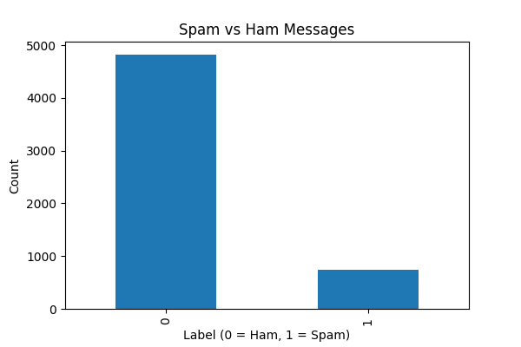

Classification Report:
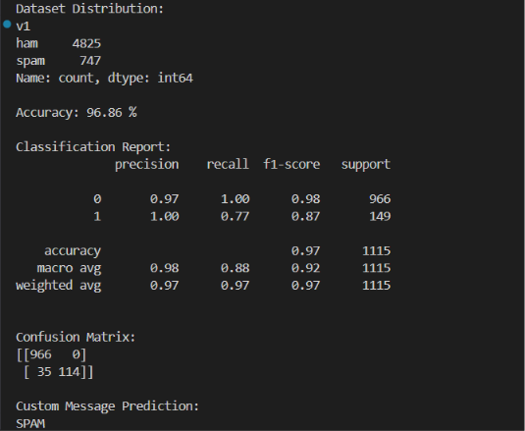

Confusion Matrix:
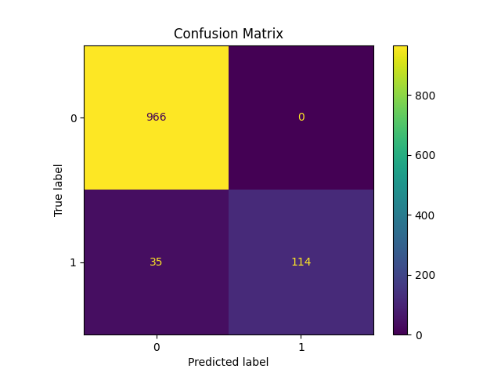
Performance Metrics:
- Accuracy: 96.86%
- Precision: 97%
- Recall: 97%
- F1 Score: 97%
Sample Prediction:
Input Message:
"Congratulations! You won a free iPhone. Click now to claim your prize."
Predicted Output:
SPAM
Advantages:
- High accuracy in spam detection.
- Fast prediction speed.
- Easy to implement and understand.
- Can be extended to email spam detection.
Applications:
- Email filtering systems.
- SMS spam detection.
- Social media message filtering.
- Customer communication systems.
Conclusion:
The Spam Mail Detector project successfully classified SMS messages into Spam and Ham categories using Machine Learning techniques. The use of TF-IDF vectorization and the Naive Bayes algorithm resulted in an accuracy of 96.86%. This project demonstrates the effectiveness of Machine Learning and Natural Language Processing in solving real-world classification problems.
References:
- SMS Spam Collection Dataset.
- Scikit-learn Documentation.
- Python Documentation.
- Pandas Documentation.
- Machine Learning with Python Resources.

